30.55: a) After one time constant has passed:
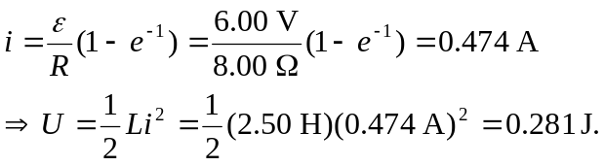
Or, using Problem (30.25(c)):
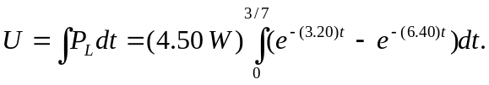
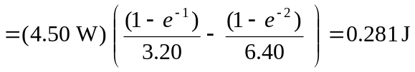

b) 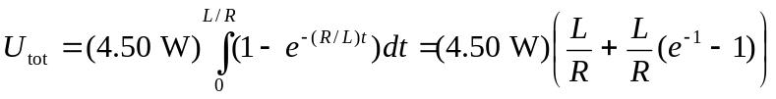
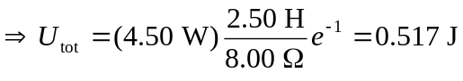
c) 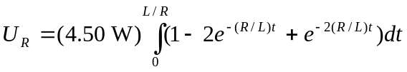
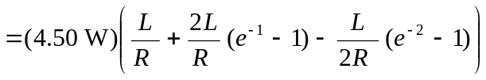
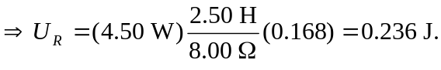
The energy dissipated over the inductor (part (a)), plus the energy lost over the resistor (part (c)), sums to the total energy output (part (b)).

